AMRIT DHURUA
dhurua96@gmail.com
Business Analyst Career Program (ChatGPT Included)
Assignment-SQL[Major]

SQL queries which I have created for this Assignment Screen Shot.
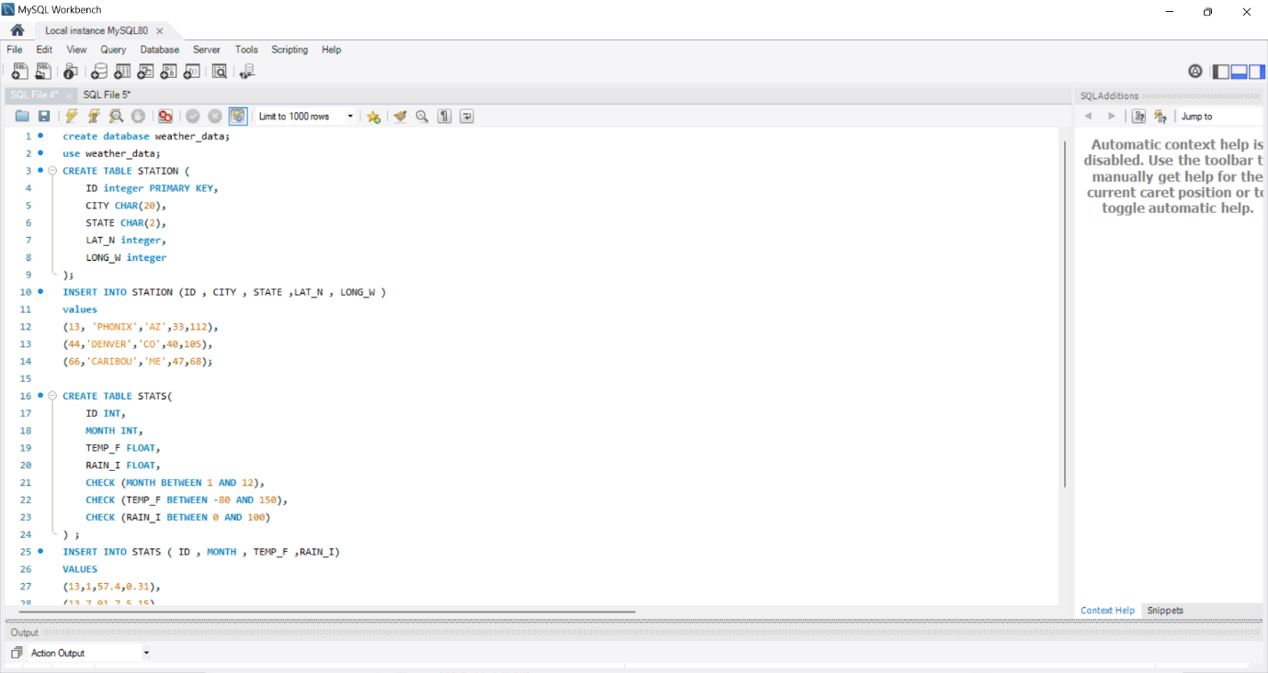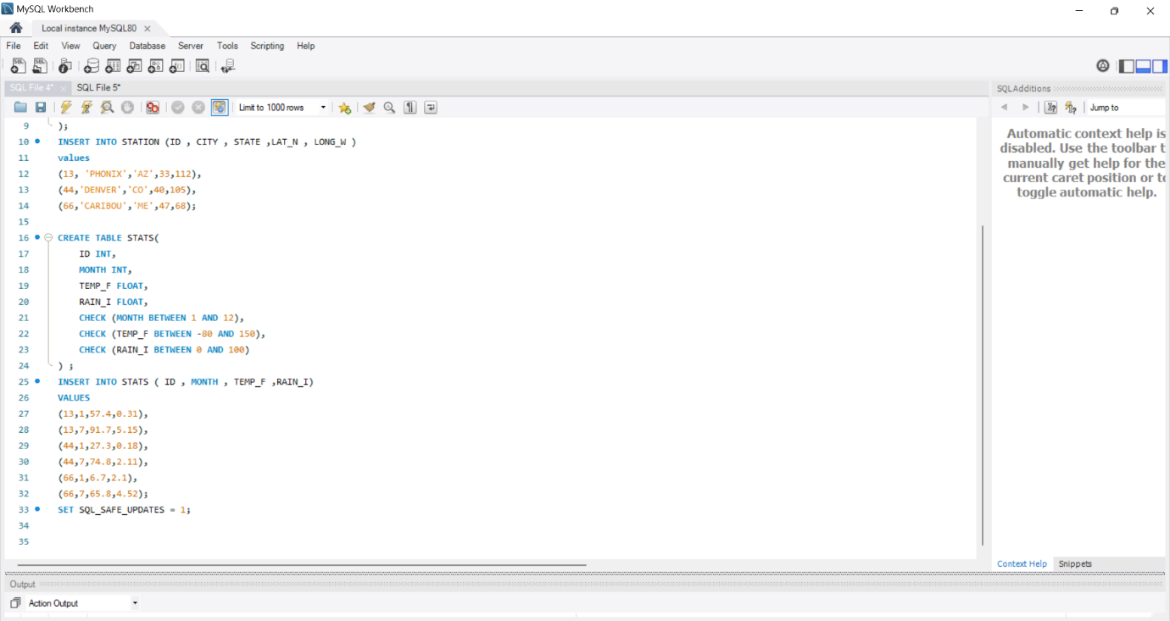
Answer 1.
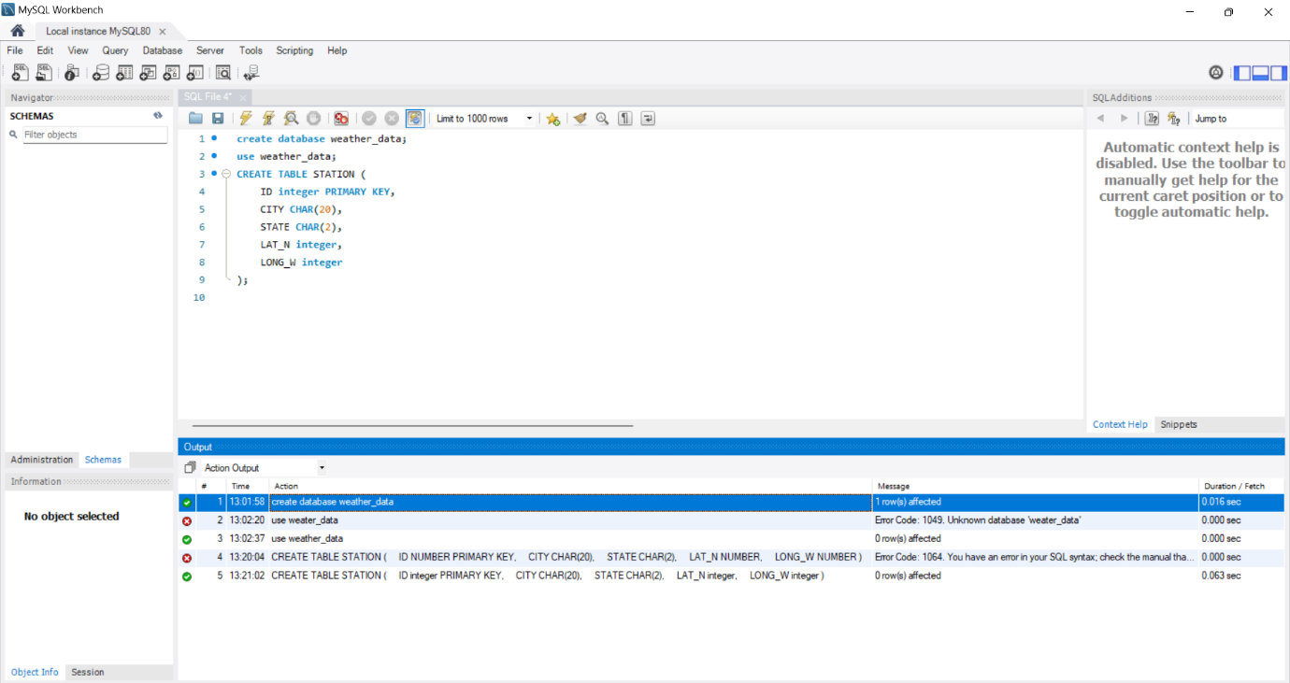
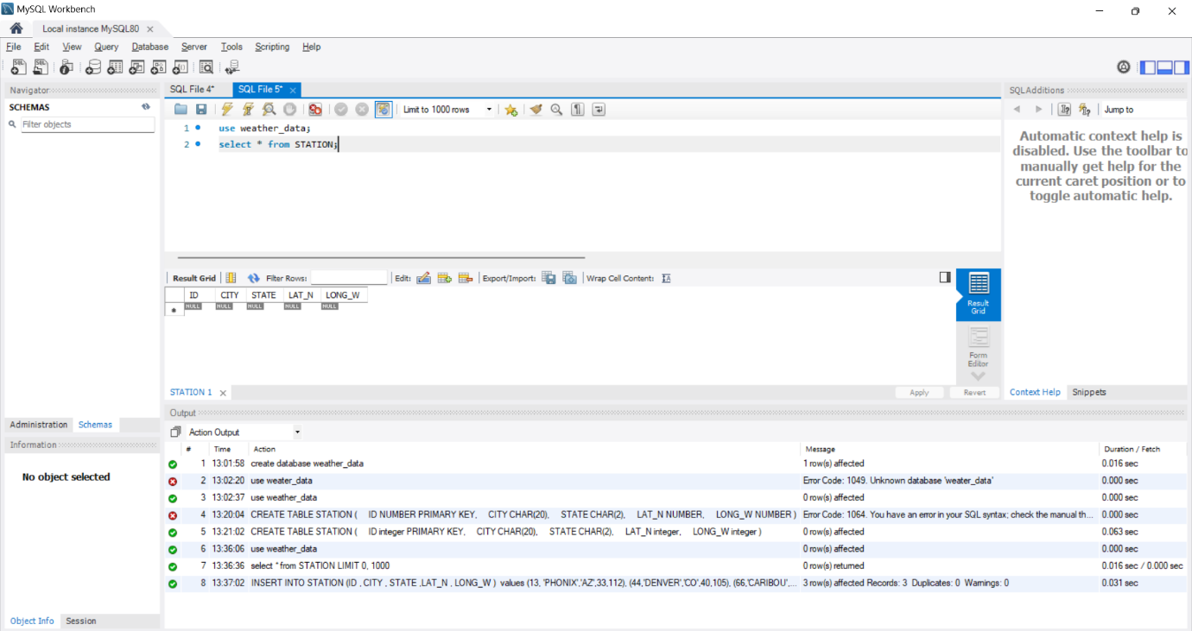
Explanation: We have used INTEGER for ID as primary key, LAT_N and LONG_W.
For CITY and STATE CHAR as a data type.

Answer 2. We can get the output using :- SELECT * FROM STATION;
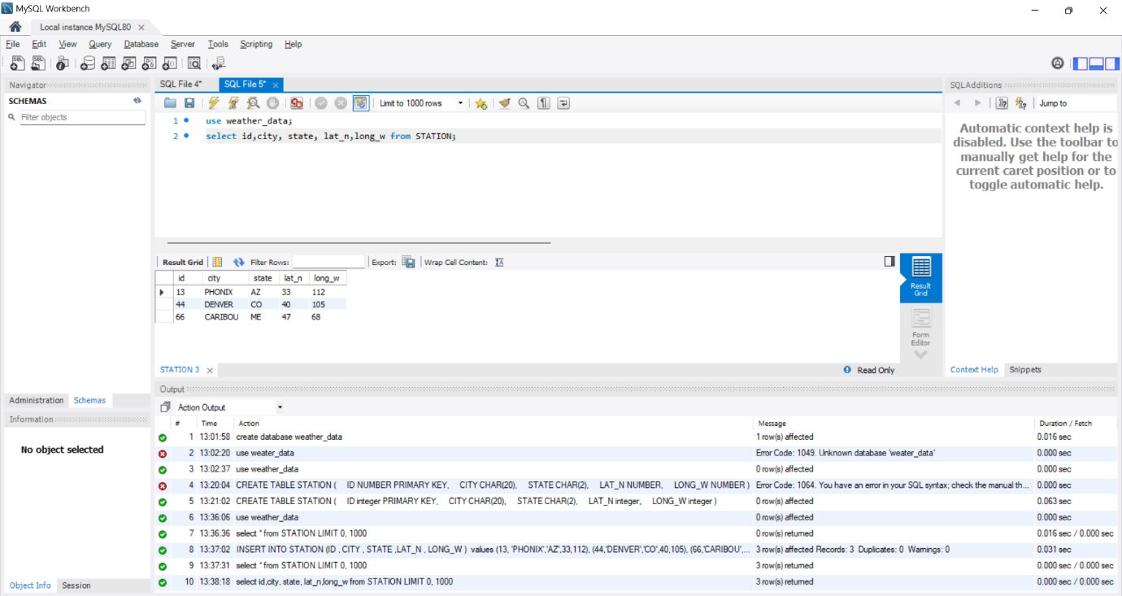

Answer 3. (SELECT * FROM STATION; ) We will get the same result as above table with null values.
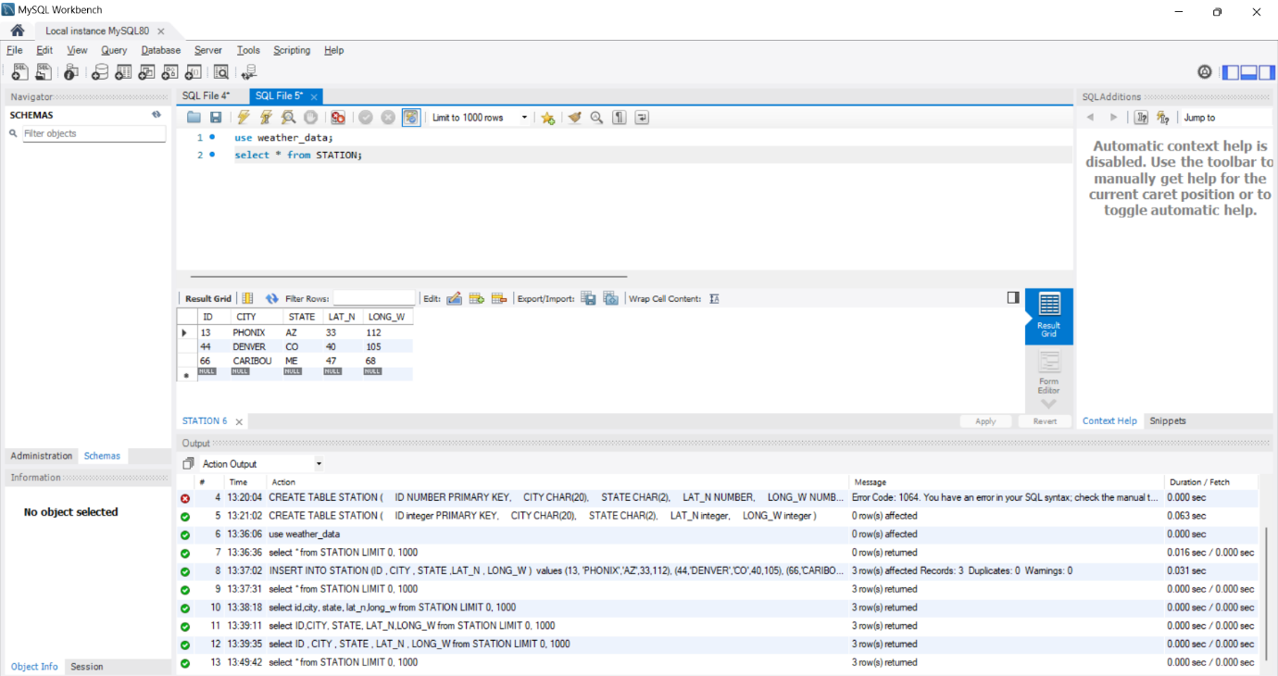

Answer 4. We have use the this query
SELECT * FROM STATION
WHERE LAT_N > 39.7;
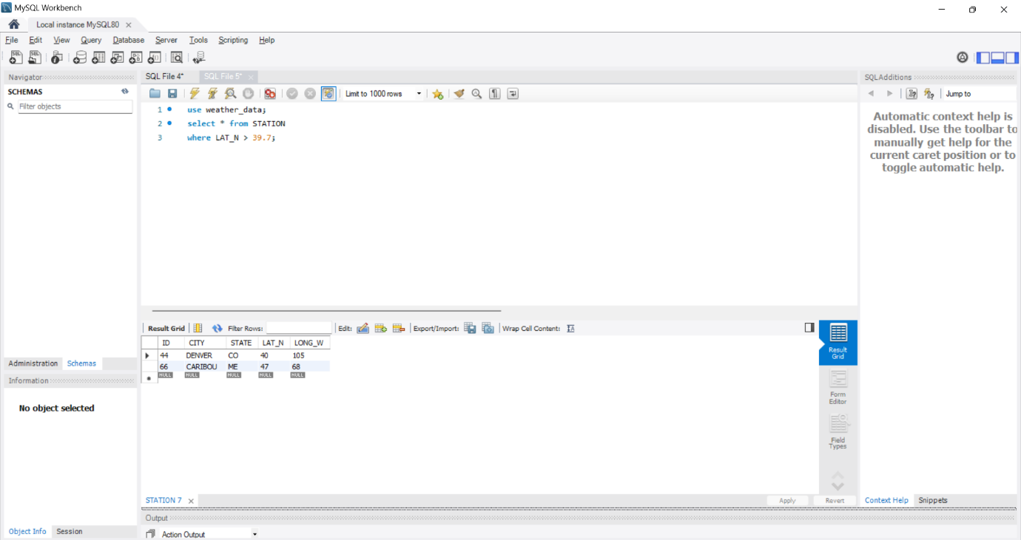

Answer 5. Here we have to create another table
Queries used are - CREATE TABLE STATS(
ID INT,
MONTH INT,
TEMP_F FLOAT,
RAIN_I FLOAT,
CHECK (MONTH BETWEEN 1 AND 12),
CHECK (TEMP_F BETWEEN -80 AND 150),
CHECK (RAIN_I BETWEEN 0 AND 100)
) ;
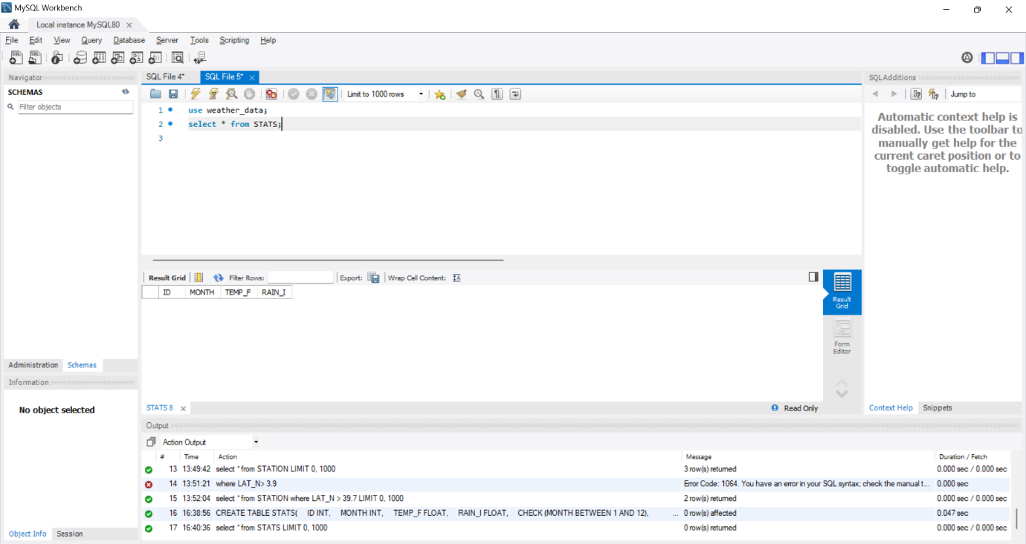

Answer 6. We have to insert the data in the table using this
INSERT INTO STATS ( ID , MONTH , TEMP_F ,RAIN_I)
VALUES
(13,1,57.4,0.31),
(13,7,91.7,5.15),
(44,1,27.3,0.18),
(44,7,74.8,2.11),
(66,1,6.7,2.1),
(66,7,65.8,4.52);
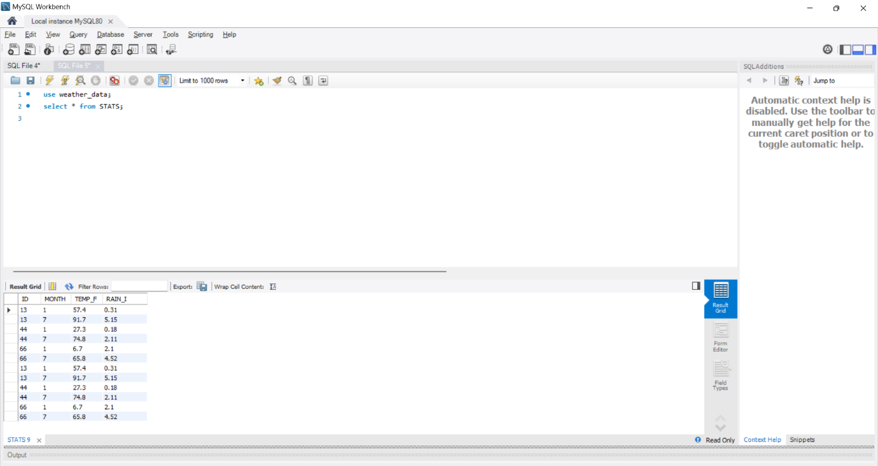

Answer 7.Here we have to combine two tables STATS and STATION
Query used :-
SELECT STATION.CITY, STATS.MONTH, STATS.TEMP_F, STATS.RAIN_I
FROM STATS
JOIN STATION ON STATS.ID = STATION.ID;
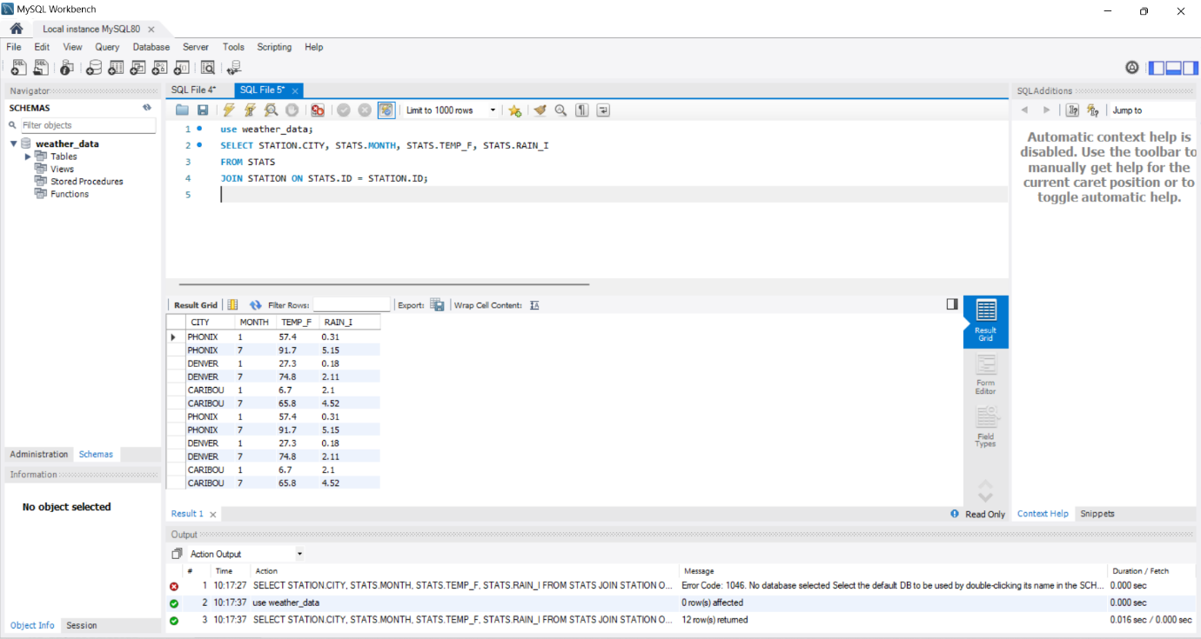

Answer 8. We have to sort the data in month first and city later query used:-
SELECT STATION.CITY, STATS.MONTH, STATS.RAIN_I, STATS.TEMP_F
FROM STATS
JOIN STATION ON STATS.ID = STATION.ID
ORDER BY STATS.MONTH, STATS.RAIN_I DESC;
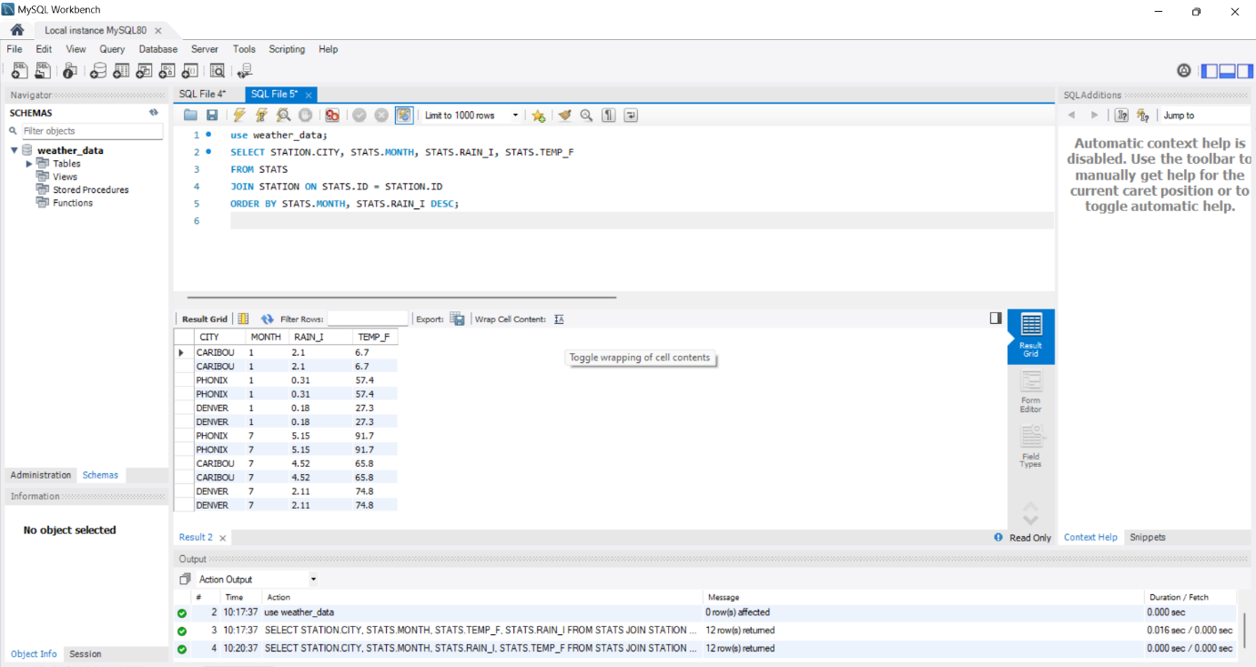
Answer 9. We have to pick data from July only
Query used
SELECT STATION.CITY, STATION.LAT_N, STATS.TEMP_F
FROM STATS
JOIN STATION ON STATS.ID = STATION.ID
WHERE STATS.MONTH = 7
ORDER BY STATS.TEMP_F ASC;
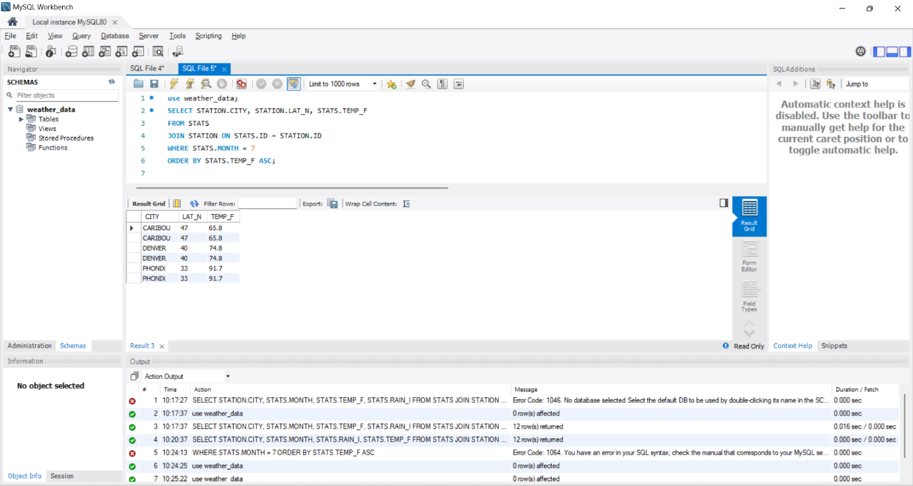
Answer 10.We have to calculate MAX , MIN and AVERAGE of each city
Query used :- SELECT STATION.CITY,
MAX(STATS.TEMP_F) AS MAX_TEMP,
MIN(STATS.TEMP_F) AS MIN_TEMP,
AVG(STATS.RAIN_I) AS AVG_RAINFALL
FROM STATS
JOIN STATION ON STATS.ID = STATION.ID
GROUP BY STATION.CITY;
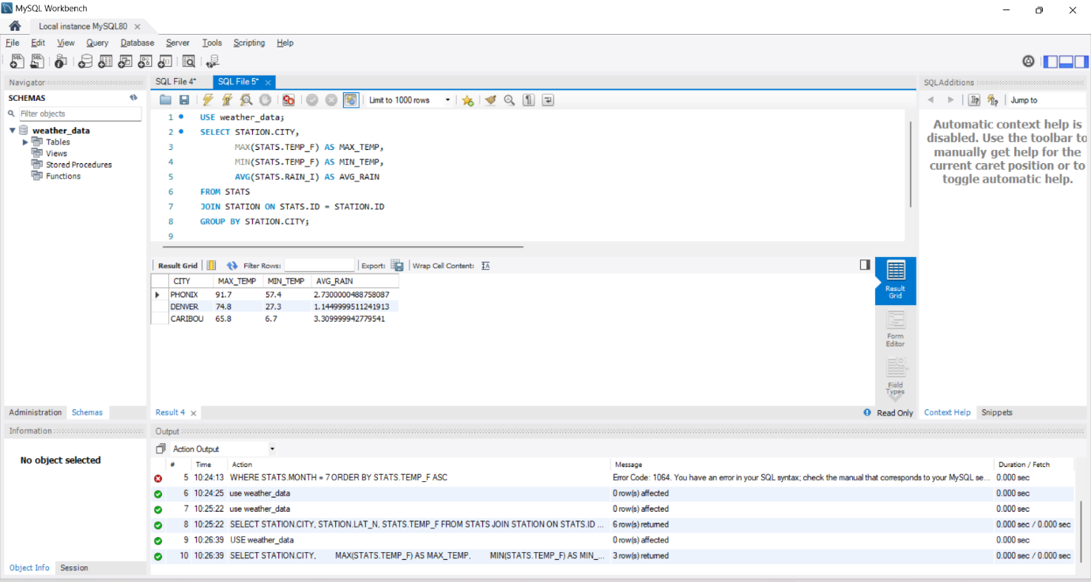

Answer 11. We have to convert temperature to celcius and rainfall to centimentr
Used query :-
SELECT STATION.CITY,
(STATS.TEMP_F - 32) * 5/9 AS TEMP_C,
STATS.RAIN_I * 2.54 AS RAIN_CM
FROM STATS
JOIN STATION ON STATS.ID = STATION.ID;
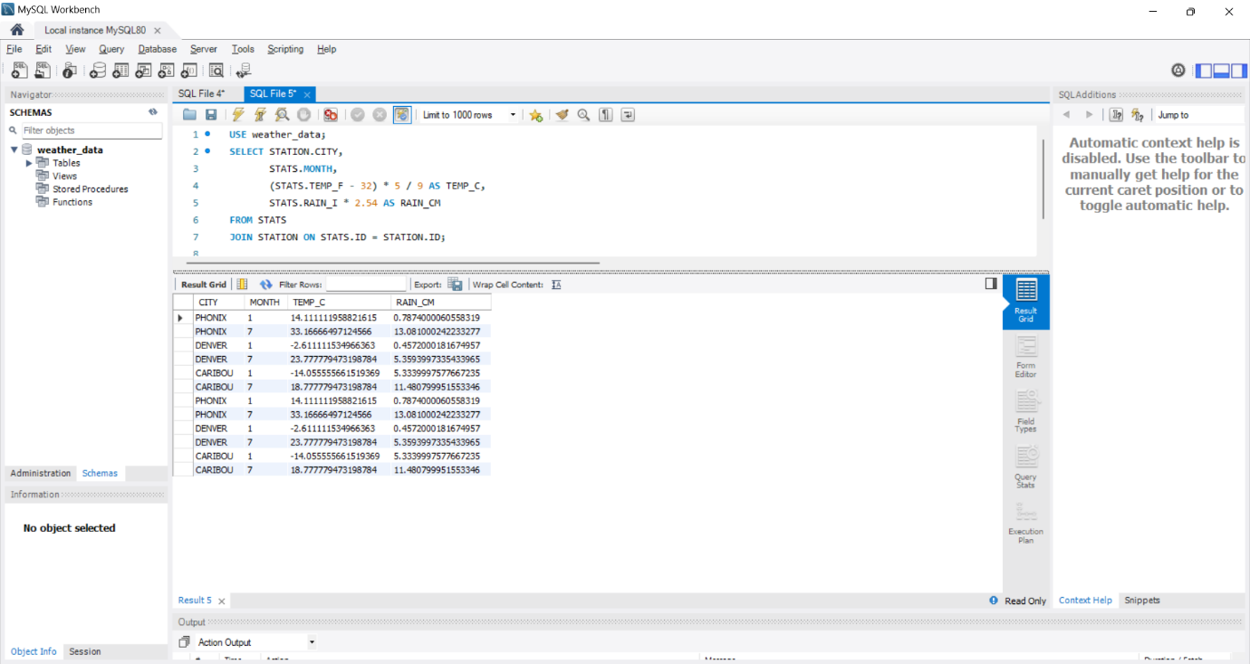

Answer 12. We have to adjust all rainfall measurements by adding 0.01 inches to account for a known error.
Query used :- UPDATE STATS
SET RAIN_I = RAIN_I + 0.01;
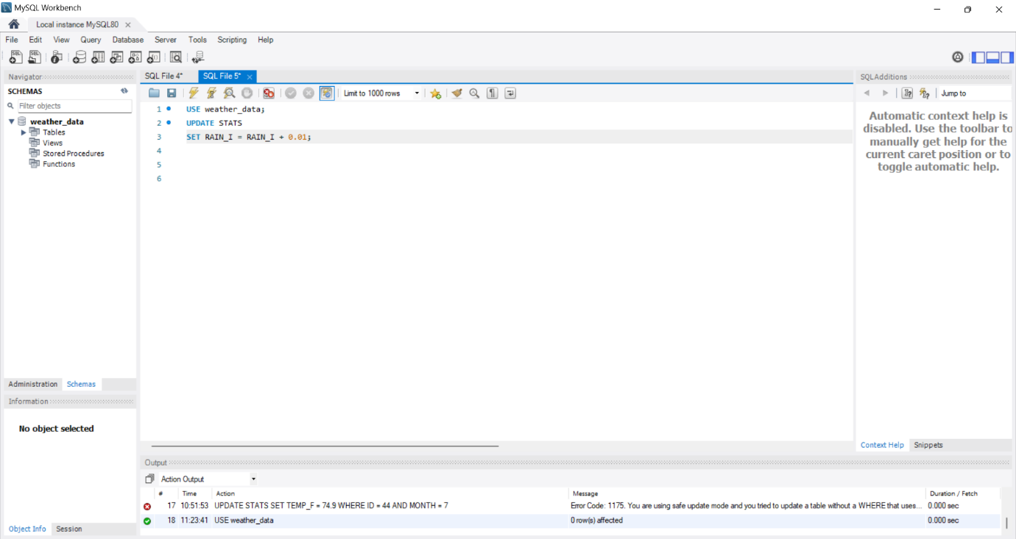
Answer 13.Our required is to update Denver's July (MONTH = 7) temperature (TEMP_F) to 74.9.
Query used:-

